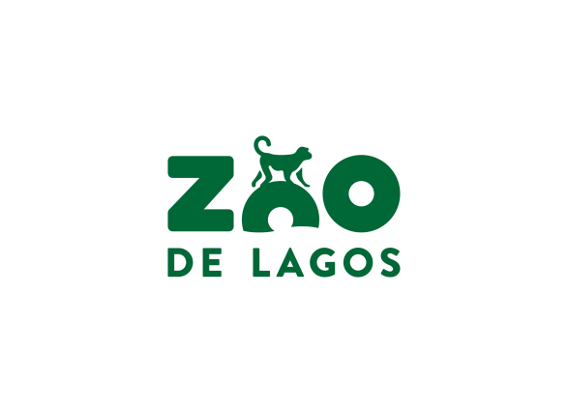
EDUCATIONAL PROGRAM
2022-2023

Liability Term
This term of liability is intended for all adults accompanying groups of children and / or young people, who visit the Lagos Zoo, whose subscription is mandatory.
We stress that. during the time spent at Lagos enclosure, the teacher / educator / companion is responsible for the behaviour of all members of the group they accompany. Therefore, we would like to ask you to keep the group always together and remember, whenever necessary, the rules and attitude of respect for animals, Zoo employees and the environment.
We highlight:
- It is forbidden to run or make noise, as it scares and disturbs the peace of the animals;
- Respect the barriers (stones, logs and ropes) that separate animals from visitors, for the safety of both;
- Do not throw litter on the floor, as we have recycling containers;
- Do not feed the animals, as they have their own balanced diets (unless the group is carrying out an activity in this sense, under the supervision of a specialized technician from the Park);
It is our intention to make the role of the teacher / educator more active, so that the visit is as profitable and organized as possible. In this way, we appreciate that you take into account the duration of the activities selected for the day of the visit and the time that you intend to stay at the Zoo. If you choose to spend more hours than the time that the group is accompanied by the park technician, we suggest to consult our suggestions for unattended activities or to develop activities under your responsibility. Therefore, it will be possible to occupy children and young people in a safe and didactic way.

I became aware of the Liability Term,

(Date and signature of the responsible supervisor/teacher)

